INCLUSION

CRITERIA

are aged 65

years and

over.

Are aged from 2

years and over in a clinical risk group

(table 1 at the end)

are at **increased**

**risk** of serious pneumococcal infection

recommended

vaccination for the PHM of clusters of severe pneumococcal disease in closed settings.

ONLY individuals who have asplenia, splenic dysfunction or chronic kidney disease require a (PPV23) booster every 5- years due to rapid decline in antibody levels.

EXCLUSION

CRITERIA

<2 years or have

previously received PPV23 over the age of 2 years, except individuals at **increased risk**

have had a confirmed

anaphylactic reaction to a previous dose of PPV23

have received

pneumococcal conjugate vaccine (PCV) in the preceding 8 weeks

are suffering from acute

severe febrile illness

PPV23 - Pneumococcal polysaccharide vaccine – PGD

– FREE NHS SERVICE – ONLY FOR LONDON AREA

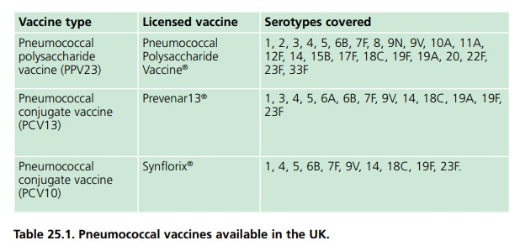

**NOT RECOMMENDED IN THE UK ATM**

**NOT TO BE USED FOR THE NHS SERVICE**

|  |  |
| --- | --- |
| **WHAT IF** | **ACTION (S) TO BE TAKEN** |
| **if aged less than 2 years PPV23 is not indicated** | ensure PCV immunisation is up to date. |
| **If PPV23 has previously been received over the age of 2 years and the individual opposed point 3 and 4 of inclusion criteria, then:** | further PPV23 is not indicated. |
| **Individuals who have received PCV in the preceding**  **8 weeks** | postpone immunisation until 8 weeks has elapsed. |
| **if the patient or carer declines treatment** | Advise them about the protective effects of the vaccine, the risks of infection and potential complications of disease. |
| **Antibody response may be impaired in those with immunological impairment and those with an absent or dysfunctional spleen.** | Document the reason for exclusion and any action  taken in the individual’s clinical records. Inform or refer  to the GP or a prescriber as appropriate. |
| **For individuals due to commence immunosuppressive treatments:** | inactivated vaccines should ideally be administered at least two weeks before commencement. |
| **Splenectomy, chemotherapy, or radiotherapy should never be delayed allowing time for vaccination.** | If the above-mentioned timings are not possible, vaccination may be carried out at any time and re- immunisation considered after treatment is finished and recovery has occurred. |
| **What will be the most precise timings:** | For **leukaemia patients**, PCV13 should be given from six months after completion of chemotherapy.  For **bone marrow transplant patients**, PCV13 should be offered 9-12 months following transplantation. |
| **Individual is suffering from minor illnesses without fever or systemic upset.** | are not valid reasons to postpone immunisation. |
| **Individuals who are a contact of pneumococcal**  **disease** | do not usually require PPV23 |
| **Pregnant and breast feeding** | Pneumococcal vaccines may be given to pregnant or breast feeding when the need for protection is required without delay. |
| **Any case of invasive pneumococcal infection or lobar pneumonia** | should prompt a review of the patient’s medical history to see if they are in a recognised risk group and if they have been appropriately immunised. |
| **When there is a doubt about exclusion criteria** | appropriate advice should be sought from a consultant paediatrician, local NHS England Screening and Immunisation Team or local Health Protection Team. |
| **If vaccinated with other allowed vaccines, what should I do?** | The vaccines should be given at separate sites, preferably in different limbs. If given in the same limb, they should be given at least 2.5cm apart. |

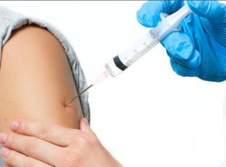

**IM**

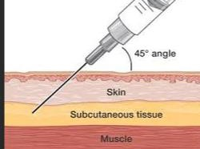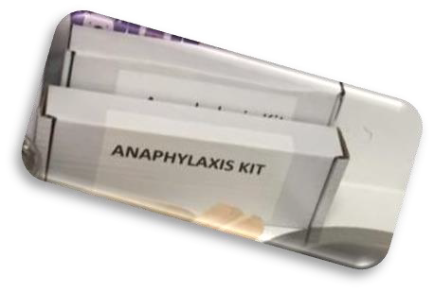

**SC: for individuals with a bleeding disorders**



**ROUTE OF ADMINISTRATION**



**Pneumococcal vaccines can be given at the SAME TIME as other vaccines such as**:

**ADVESE REACTION: PPV23**

**Storage: PPV23**

The polysaccharide vaccine should be inspected before being given to check that it is clear and colourless.

**Record Keping**:

8 years after the PGD expires if the PGD relates to adults only and for 25 years after the PGD expires if the

PGD relates to children only, or adults and children..

Mild soreness and induration at the site of injection lasting one to three days and, less commonly, a low-grade fever may

occur. The most common systemic adverse events reported are fatigue, myalgia, and headache.

DTaP/IPV/ Hib/HepB, 4CMenB, MMR, MenACWY, Hib/MenC, Rotavirus, shingles vaccine, Zostavax and influenza.

Upload the Data to the SONAR platform who will send the data to the GP

**Who to share records with:**

Evidence of appropriate (CPD) for clinical skills relating to immunisation and management of anaphylaxis. A Patient Specific Direction (PSD) may be required to administer the vaccine in line with updated recommendations that are outside the criteria specified in this PGD. **Example:** Individuals at risk of frequent or continuous occupational exposure to metal fumes (such as welders) should be considered for immunisation considering exposure control measures in place. This indication is outside the remit of this PGD.

**Trainings REQUIRED**

|  |  |
| --- | --- |
| **HOW CAN I ENGAGE MY PATIENTS:** | |
| Pharmacy staff should identify patients for whom vaccine is recommended and use all opportunities to ensure that they are appropriately immunised, for example, when immunising against **influenza or at other routine consultations**. | **Individuals at occupational risk** There is an association between exposure to metal fume and pneumonia, particularly lobar pneumonia, and between welding and invasive pneumococcal disease PPV23 (in those who have not received PPV23 previously) should be considered for those at risk of frequent or continuous occupational exposure to metal fume (such as **welders**) considering the exposure control measures in place. Vaccination may reduce the risk of pneumococcal disease but should not replace the need for measures to prevent or reduce exposure. |

**Table 1:**

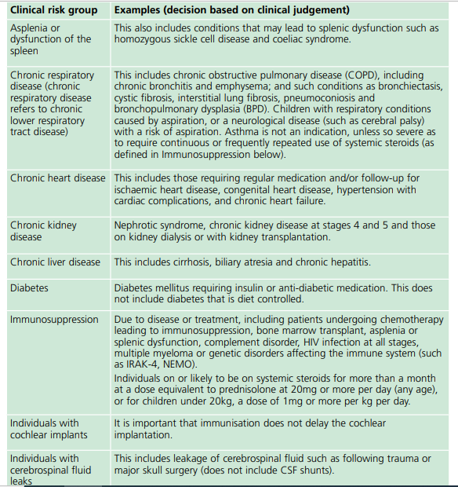

**Table 2:**

